**Program 1**

1. **Find the sum of natural number using Recursion**

**Solution:**

*Triangle:*

def Rec(n):

if (n<=1):

return n

else:

return (n+Rec(n-1))

a=int(input("Enter the no. of naturalnumbers you want to find the sum : "))

print(Rec(a))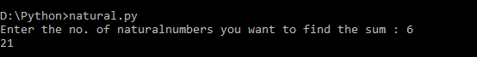

**Program 2**

1. **WAP to find the factorial of the number using Recursion**

**Solution:**

def factorial(n):

if(n==0):

return 1

else:

return(n*factorial(n-1))

a=int(input("Enter the number to find the factorial of the number: "))

print("The factorial of the number is : ",factorial(a))



**Program 3**

1. **Write a menu driven Program for banking system and implement the following methods CreateAccount()**

**Deposit()**

**withdraw()**

**display()**

**Rate of interest()**

**Solution:**

class BankAccount:

# constructor or initializer

def __init__(self, name, money):

self.__name = name

self.__balance = money # __balance is private now, so it is

only accessible inside the class

def deposit(self, money):

self.__balance += money

def withdraw(self, money):

if self.__balance > money :

self.__balance -= money

return money

else:

return "Insufficient funds"

def checkbalance(self):

return self.__balance

def interest(self):

return self.__balance*0.05

n=0

while (n!=6):

print("Welcome!")

print("To Open new account press 1")

print("To Check Balance press 2")

print("To withdraw press 3")

print("To deposit press 4")

print("To check interest press 5")

print("To exit press 6")

n=int(input("Enter Your Choice: "))

if(n==1):

name=str(input("Enter Name: "))

ia=int(input("Enter Initial Amount: "))

b1 = BankAccount(name, ia)

elif(n==2):

print("Balance is ",b1.checkbalance())

elif(n==3):

ia=int(input("Enter Amount: "))

b1.withdraw(ia)

print("Balance is ",b1.checkbalance())

elif(n==4):

ia=int(input("Enter Amount: "))

b1.deposit(ia)

print("Balance is ",b1.checkbalance())

elif(n==5):

print("Interest for 1 year on",b1.checkbalance(),

"is",b1.interest())

print("\n")

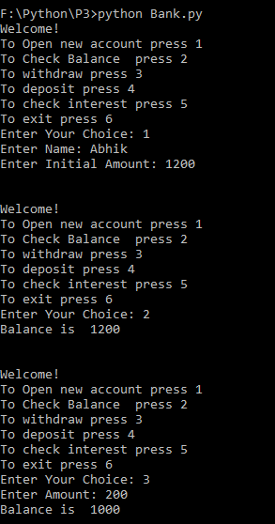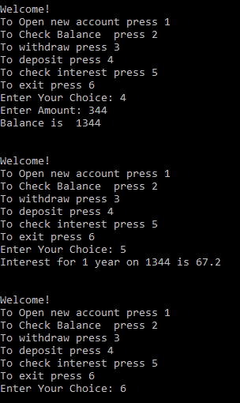

**Program 4**

1. **Write a menu driven Program to display various function**

**Solution:**

#Menu driven program to find factorial recursion reverse and palindrome

def factorial(n):

if (n==0):

return 1

else:

return (n*factorial(n-1))

def reverse(str):

str=str[::-1]

return str

def Armstrong(num):

order = len(str(num))

add=0

temp=num

while(temp>0):

digit=temp%10

add=add+(digit**order)

temp=temp//10

if(num==add):

print("The number is armstrong")

else:

print("The number is not armstrong")

def Pallindrome(str):

if(str==reverse(str)):

print("The given string is pallindrome")

else:

print("The given string is not pallindrome")

def Prime(num1):

flag=1

for i in range(2,num1):

if(num1%i==0):

flag=0

break

if(flag==1):

print(num1,"is Prime ")

else:

print(num1,"is not Prime")

def Fibo(a,b,n):

print(a,b,end=" ")

while(n-2):

c=a+b

a=b

b=c

print(c,end=" ")

n=n-1

ch=0

while ch!=7:

print("\n\n1 : Factorial")

print("2 : Reverse")

print("3 : Fibonacci")

print("4 : Check Armstrong")

print("5 : Check Pallindrome")

print("6 : Check Prime")

print("7 : Exit")

ch=int(input("Enter Your choice : "))

if (ch==1):

a=int(input("Enter the number to find the factorial : "))

print("The Factorial of the num is : ",factorial(a))

elif(ch==2):

b=input("Enter the string to reverse the : ")

print("The reversed string is : ",reverse(b))

elif(ch==3):

c=int(input("Enter the number till which you want to find the Fibonacci series : "))

Fibo(0,1,c)

elif(ch==4):

d=int(input("Enter the number to check the number is armstrong or not"))

Armstrong(d)

elif(ch==5):

e=input("Enter the string to check whether the number is pallindrome or not")

Pallindrome(e)

elif(ch==6):

f=int(input("Enter the number to check the number is Prime or not :"))

Prime(f)

elif(ch==7):

print("You are Being Logged out......")

else:

print("You have selected a wrong choice!!!")

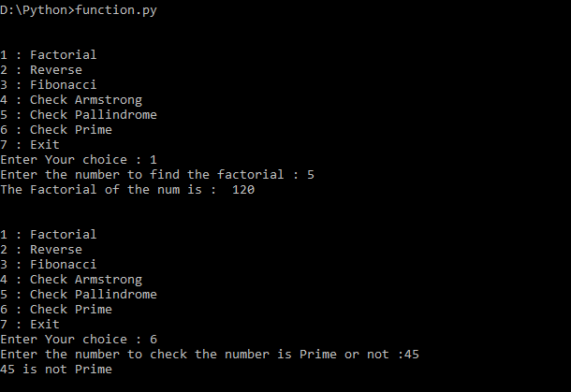

**Program 5**

1. **Write a Program to convert the number from decimal to binary using Recursion**

**Solution:**

def Convert(n):

if n > 1:

Convert(n//2)

print(n%2,end = ' ')

a=int(input("Enter the decimal number to conver into Binary : "))

Convert(a)